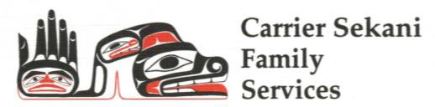 Health & Wellness Program

Community Mental Health, Aboriginal Child & Youth Mental Health, Addictions Recovery Program, Indian Residential School Program (IRSS), Atsoo, Cultural Support

|  |  |
| --- | --- |
|  |  |

**Our Offices:**

|  |  |  |  |
| --- | --- | --- | --- |
| Burns Lake  Ph. (250) 692-2387  **Referral emails:**  **Community Mental Health -** [**communitymhreferral@csfs.org**](mailto:communitymhreferral@csfs.org)  **Child and Youth Mental Health –** **cymhreferral@csfs.org** | Fort St. James  Ph. (250) 996-7640 | Vanderhoof  Ph. (250) 567-2900 | Prince George  Ph. (250) 564-4079 |

Referral Form: For Family & Individual Services

|  |  |  |  |
| --- | --- | --- | --- |
| Individual Seeking Support: | | Date of Birth: | |
| Home Address: | | | |
| Primary First Nation/Band: | Home Community: | | |
| Home Phone:  Cell Phone: | Mailing Address:  (if different than home) | | |
| Parents/Legal Guardians (if client is a minor): | | | |
| Other people in the home (eg. partners, parents, siblings, children): | | | |
| Please list any other adults involved (if applicable): | | | |
| Other Children (if applicable): | | | |
| Reason for this Referral: | | | |
| Is this a request for Tele-health/Video conference services? | | Yes | No |
| Is client/family involved aware that this referral is being made? | | Yes | No |

|  |
| --- |
| **Service referred to:**  **Community Mental Health**  **Child and Youth Mental Health**  **Addiction Recovery Program**  **IRSS**  **Nanki Nezulne (2SLGBQT+)**  **Sexual Violence Support Program**  **Atsoo Program**  **Cultural Support** |
| **Referral comes from:** |
| Name: |
| Agency: |
| Signature: |

|  |  |
| --- | --- |
| **Confirmation of Referral Received (For HAWP Use only) Complete and send a copy back to referral source** | |
| Employee: | Date: |
| Signature: | Phone Number: |